[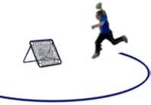](http://www.bing.com/images/search?q=tchoukball+rules&view=detail&id=C83630754BB1940ACF3D468959D47495FA615BE5&first=0&FORM=IDFRIR)[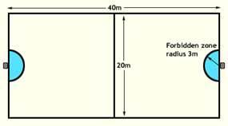](http://www.bing.com/images/search?q=tchoukball+court&view=detail&id=66BE707F5131961B4081E1E10CAA0BE1E875F6FA&first=0&FORM=IDFRIR)

***You can............***

1. ***Move 3 steps ONLY with the ball***
2. ***Pass ONLY 5 times before you MUST shoot***
3. ***Shoot at BOTH frames***
4. ***Only have 3 seconds ‘on’ the ball***

***To Score a point......***

***1. Throw the ball at the frame***

***2. The ball rebounds and lands on the court – but NOT in the forbidden zone***

***To lose a point......***

***- Ball rebounds into forbidden zone; ball rebounds out of play, ball rebounds and hits the thrower and ball MISSES the net.***

***Fouls...............***

***1. Interfering with a pass or movement of player***

***2. Making 6 passes before shooting***

***3. Dropping the ball***

***4. Stepping out of bounds with the ball***

***5. Touching the ball with your foot or below the knee***

***Any Foul = loss of possession***