CHEERTASTIC
2016
CONTENTS
- COMPETITION BASIC INFO
- CHEERLEADING RULES & REGULATIONS
- DEDUCTIONS
- CHEERLEADING SCORE SHEETS
- POM DANCE RULES & REGULATIONS
- POM DANCE SCORE SHEETS
- ENTRY FORMS (due back to rcunningham@copleyacademy.org.uk by 27th June)

***PLEASE NOTE CHANGES FOR THIS COMP***
There will be 2 categories in this competition
- Cheerleading (which involves stunting & tumbling)
- Pom dance (which is what we have previously competed with)

Date: Wednesday 6th July
Venue: Copley Sports Centre
Time: 12.45pm team registration/spectator arrival
1.15pm Primary competition

Other Info: Team entry is free (please fill in from below)

All entries MUST be via the Tameside School Sports Partnership website by Monday 27th June 2016.
Any teams who do not enter by this date will NOT be allowed to compete as running orders will be sent out and will NOT be changed. This entry date is NON NEGOTIABLE.

- AGE GROUPS
Primary School- Years 1 to 6
KS1 – 75% of the team must be in KS1
KS2 – 75% of the team must be in KS2
- SQUAD / TEAM
30 maximum / 5 minimum
The aim of the competition is to develop grassroots participation therefore mixed teams are welcome.
- Music
All squads must provide TWO copies of their music on CD on the day, this must be clearly labelled with school name and instructions (times etc). Squads must also have a designated person to operate the music for their performance. Music for each performance should begin at the start of a CD. Any music deemed inappropriate with incur a 10 point deduction.
- Kit
Participants must wear PE kit or appropriate costumes
- EQUIPMENT
Props may be used throughout the routine.
- AWARDS
1st, 2nd and 3rd place in each group (KS1, KS2,) will receive a school trophy.
Additional awards will also be given in the following category:
Cheerleader of the day
School spirit award
- SPECTATORS
Tickets will be priced at £4.00 and will be available via www.etickets.to/buy/?e=13312
Please note – NO TICKET, NO ENTRY – this is a paperless ticket system, spectators WILL NOT be sent a paper ticket. Their names will be confirmed upon entry.
*****SCHOOLS PLEASE MAKE THIS CLEAR TO YOUR PARENTS AS THIS BEING MISCOMMUNICATED BY SCHOOLS TO THEIR PARENTS USUALLY CAUSES ISSUES*****
- JUDGES
Judges will be comprised of industry professionals and Tameside Dance Leaders. The judges decisions are final and we expect all teams to show good team spirit by supporting and applauding the judges decisions.

CHEERLEADING RULES & REGS
****NEW CATEGORY****
Must be coached by a fully qualified cheer coach
**PLEASE SEE SEPARATE DOCUMENT OR UKCA RULES FOR GENERAL CHEER RULES**
COMPETITION REQUIREMENTS
Perform a routine of Cheer skills, movement and vocals
which should be dynamic and exciting, incorporating all the compulsory elements Audience participation and props are encouraged (i.e. Poms, megaphones, banners, signs/cards, flags etc) Cheer uniform MUST be worn (see glossary)
- Compulsory Elements
Vocal Skill (Cheer/Chant/Sideline)
Stunts
Pyramid
Cheer Jumps
Tumbling
Dance
Cheer Arm Motions

- Beginning & End of Routine
The routine must be performed on the matted performance area provided Cheerleaders are not allowed outside the performance area once routine has started
All Cheerleaders must start the routine with at least one foot on the ground
All Cheerleaders must come to a complete stand still before beginning their routine
- Time
Routine maximum time limit is 2:30 minutes
Timing will begin on the first note of music, the first vocal command or the first Cheer movement and stop with the last note of the music or when all Cheerleaders come to a stationary position
The judges will continue to mark the final dismounts until they are safely on the ground

- Music
Teams must provide their own music track with backup, on CD, iPod or iPhone
A representative of the team must start and stop the music

DEDUCTIONS
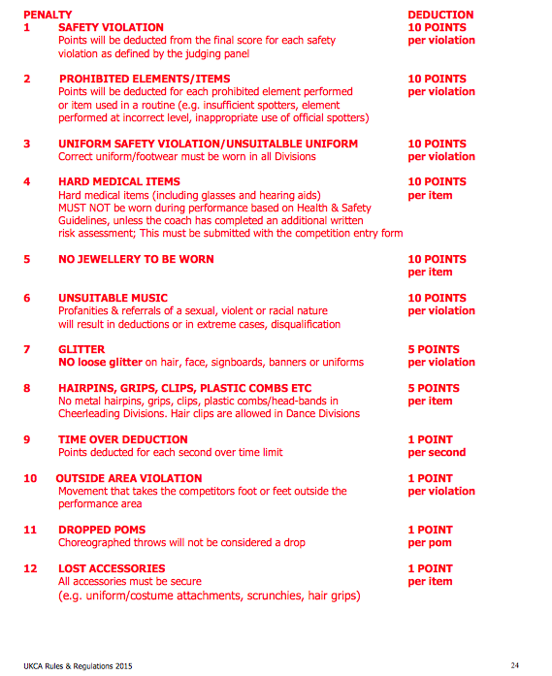

TAMESIDE CHEER FEST 2016
CHEERLEADING SCORE SHEETS
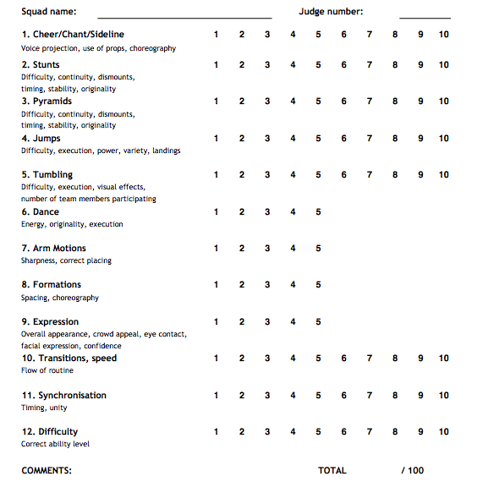

TAMESIDE CHEER FEST 2015
POM DANCE RULES & REGS

- COMPETITION REQUIREMENTS
Perform any type of dance routine, which may encompass a variety of dance styles such as (but not limited to) Jazz, Funk, Pop, Lyrical, Hip-hop, Street etc.
Poms must be used by participants at some point during the routine (optional for males)
Additional props may be used
- Compulsory Elements
Vocal Skill (Cheer/Chant/Sideline)
Cheer Arm Motions
Cheer Jumps

- Prohibited
Pyramids
Stunts
Tumbling
- Timing
All team routines will be a maximum of 2:30 minutes
Timing will begin on the first note of music, the first vocal command or the first movement and stop
with the last note of the music or when all Cheerleaders come to a stationary position

TAMESIDE CHEER FEST
POM DANCE SCORE SHEET

TEAM NAME JUDGE NO.
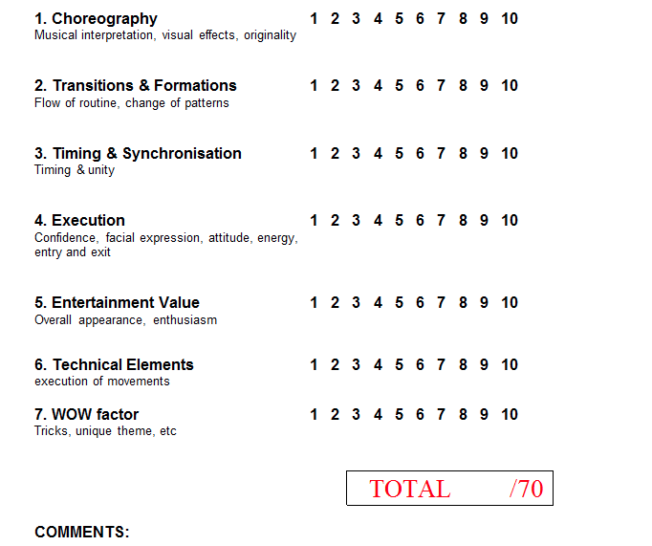

ENTRY FORM
Please email to rcunningham@copleyacademy.org.uk before 27th June 2016

CATEGORY: (please circle/highlight) CHEERLEADING POM DANCE

KEY STAGE: (please circle/highlight) KS1 KS2

Squad name:

School :

Coach/Teacher:

Relevant qualifications:

NAME | KEY STAGE | M/F | PHOTO CONSENT

