Ultimate Frisbee
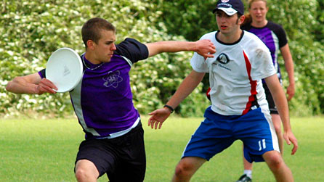
Learn how to play Ultimate Frisbee with this guide to the basics of the sport.
Ultimate Frisbee is a fun and fast-flowing sport played with a Frisbee, commonly called a disc. Ultimate, as the players call it, is a non-contact, mixed team sport that can be played socially with a group of friends or as part of a club at a tournament.

Facts and Figures
Team:
Seven players
Pitch:
100m long x 37m wide
Endzones:
18m deep at each end of the pitch
How to play
A point begins with both teams on their endzone lines. One team throws the disc to the other team to start the point. The team with the disc is on the offensive and it is their aim to score a point. A point is scored by catching the disc in the opponent's endzone, just like in American football. Similar to netball, the player in possession of the disc, the thrower, can pivot, but they cannot run. To move upfield, towards the opposing team's endzone, the disc has to be thrown between members of the team.
The defensive team generally 'man-mark' their opponents aiming to pressure them into 'turning over' without making physical contact. The defensive player who marks the thrower is called the force. The force counts aloud from one to 10, upon reaching 10, the disc is 'turned over'. While counting the force also attempts to stop the thrower throwing the disc to one side of the field. The other defensive players try to cause a 'turnover' by catching the disc themselves or knocking it to the ground. Following a 'turnover' the teams swap roles.
Players can take rolling substitutions at the end of every point and the winner is the first team to reach a predetermined number of points, often around 13.

Beaters: 1 player from each team used as a ‘beater’ with a light sponge type ball. They can dispossess the player with the Frisbee by throwing the ball and hitting the Frisbee player anywhere below the knee. If they are hit – Frisbee dropped and play turned over.
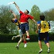
Working with others
Ultimate places a large emphasis upon teamwork. Communication between the seven players on the pitch is essential or a 'turnover' will result. When on the offensive, the six players without the disc need to work together so that one of them gets into a space within the 10 seconds that a player is allowed to hold onto the

