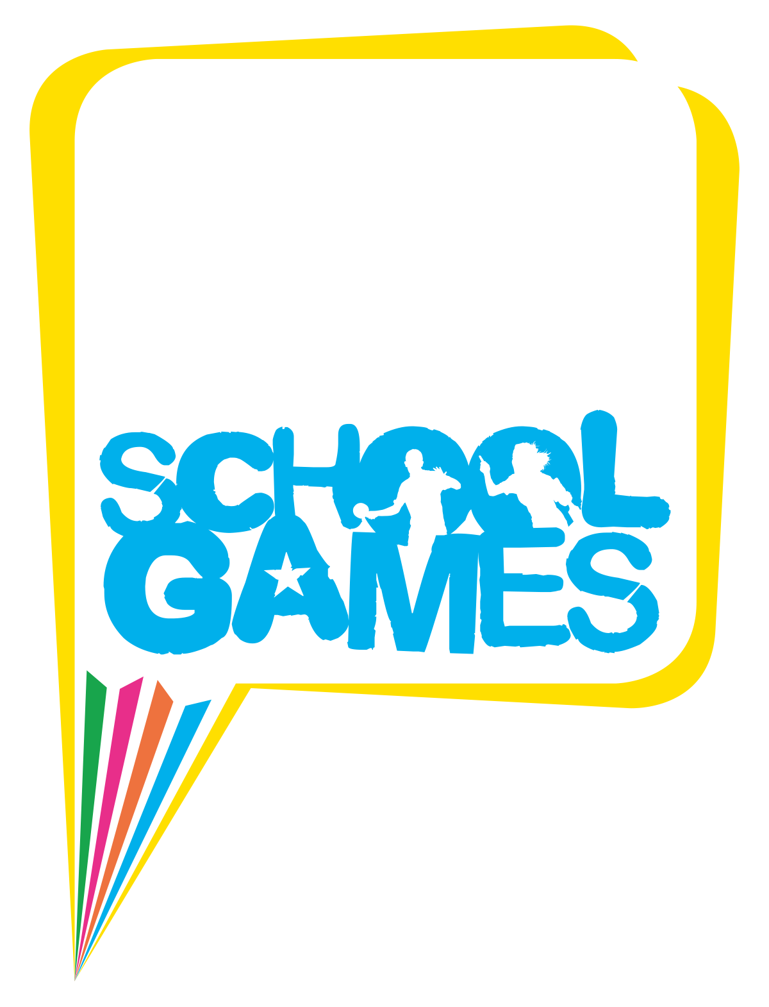



GREATER MANCHESTER
SCHOOL GAMES 2017

YEAR 5/6 & 7/8 DODGEBALL COMPETITION

Wednesday 5th July 2017
The Armitage Centre (Opening Ceremony at Outdoor Arena first)

SCHOOL GAMES BACKGROUND INFORMATION:

The Greater Manchester School Games aims to further revive the culture of competitive sport in schools. This exciting new concept will harness the power of the Olympics and Paralympics and is designed to motivate and enthuse more young people than ever before to participate in high quality, meaningful competition within and across schools, supporting them in achieving their own personal best in sport and in life.

The competition will run across three distinct, but integrated levels (see below) providing a simple and progressive pathway culminating in a multi sport festival (level 3) that will showcase the very best of competitive sport across the County.

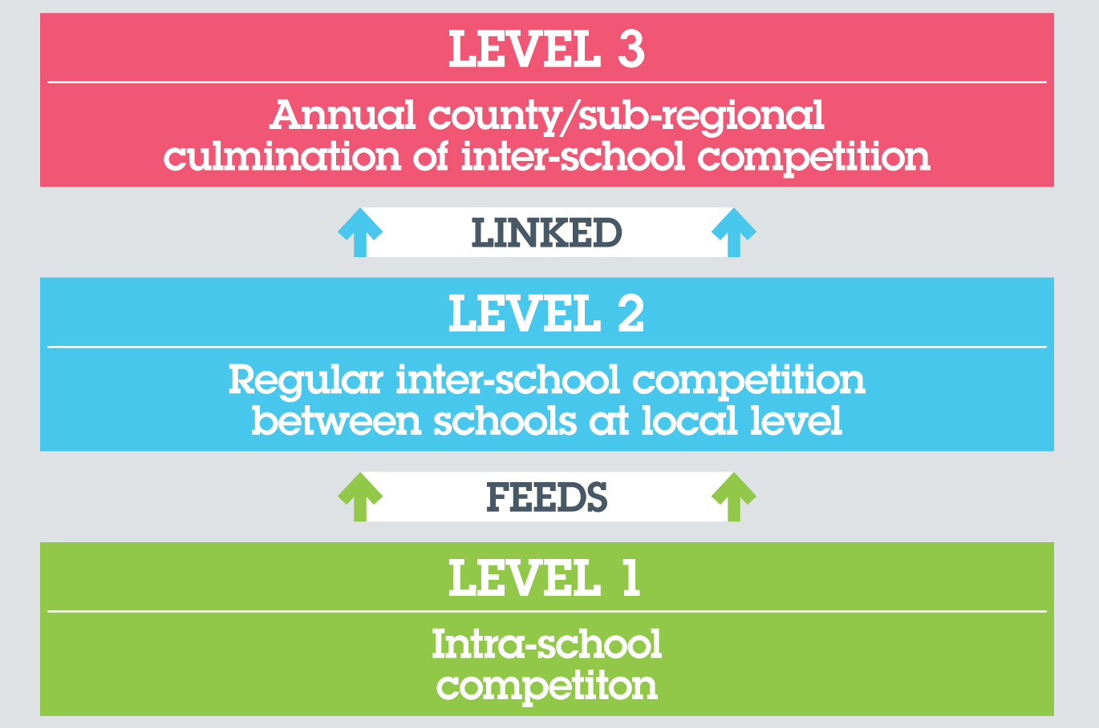

Level 3 – Greater Manchester School Games

Level 2 – Inter-school competition

Level 1 – Intra-school competition

Teams from Primary, Secondary and Special Schools will win the right to compete in the Level 3 Games having qualified through their local level 2 inter-school competitions. The ‘Summer Games’ will feature thirteen sports; all of which will be delivered simultaneously utilizing a number of the City’s world class sporting facilities.

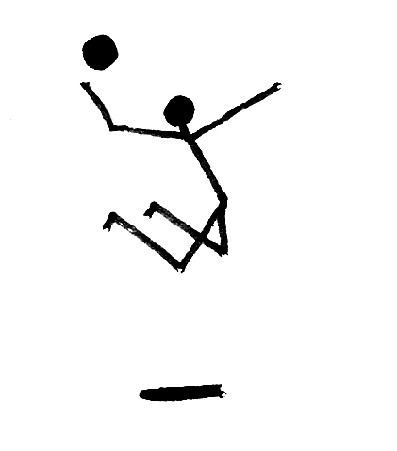

COMPETITION PATHWAY:

In partnership with Mr Dodgeball and British Dodgeball, the Greater Manchester Local Organising Committee proudly presents the Year 5/6 Mixed and Year 7/8 Boys and Girls Dodgeball Competitions.

Dodgeball has many advantages, but none more than its absolute accessibility. It is played right across the world by people of all ages, sexes and sporting abilities. It is very simple to learn, and ‘everyone’ has the ability get involved as part of a team.

Dodgeball has been played at a local level for many years, however the formal structure of the sport that British Dodgeball continues to provide has given it the ability to grow at an unprecedented pace within the UK.

British Dodgeball hopes to raise participation of the sport through School Games and provide more children of school age with the opportunity to play the sport competitively.

The competition adopts a simple pathway as follows:

1. SGO Area/Borough Events

Primary Schools within an SGO Area/Borough will be encouraged to enter the first stages of the competition at a venue local to their school. The winning school from the Borough will then be invited to the School Games County Final.

2. Greater Manchester School Games County Final

This stage of the competition will be organised by Mr Dodgeball and will comprise of 10 schools in each competition representing the 10 Boroughs of Greater Manchester.

NB An athlete can only represent their school in one sport at the GM School Games County Final.

STANDARD RULES:

Age Groups Year 5/6

- All players must be in school Years 5/6.
- A mixture of year groups can be used, or the team can be from all one year group.

Squad Years 5/6

- Each squad can include up to 8 players.
- There should be 6 players on court at any one time
- Teams can be mixed, consisting of boys &/or girls.

Age Groups/Team Composition Years 7/8

- All players must be in school Years 7/8.
- A mixture of year groups can be used, or the team can be from all one year group.
- Girls and boys will compete Separately

Court/Equipment Requirements

- A badminton-sized court
- Size 3 Balls (Years 5/6)

- Size 4 Balls (Years 7/8)

Competition format
- Each game will be a maximum of three minutes long.

Playing the Game

STARTING THE GAME
- 2 teams of 6 players each begin the game with one foot or hand touching the end line or wall
- 3 balls begin in the centre zone
- On the referees whistle a maximum of 2 players from each team race to collect a ball from the centre zone
- The balls must be passed all the way back to the wall or back line
- On collecting a ball at the back line the players are free to throw the ball at the opponent, in order to get them ‘OUT’

PLAYING THE GAME
- A Game = 2- 3 minutes
- You can use a ball in your possession to block a thrown ball
- Headshots do not count and both players stay in, deliberate heading may be penalized by the referee and the player may be out.

FIVE SECOND RULE AND VALID THROW
Under 16s
- The team with the majority of balls has 5 seconds to throw the balls in their possession.
- The team with the least balls can always hold on to 1 ball
- The leading team in a game must make a valid attempt when throwing the balls (Valid attempt = throw with intent to get someone out), leniency usually given with younger participants, however if it is deemed that continuous invalid throws are done purposely the referee can send them out of the game.
Under 12s
- All Players have 5 seconds to throw the ball
- Players are not allowed to roll the ball or deliberately throw the ball out of play

ELIMINATION 'GETTING OUT'
- Hit by a Dodgeball thrown by an opponent without a bounce
- An opposition player catches a Dodgeball that you have thrown
- Stepping over the centre zone lines or out of the court
- The ball you are holding is knocked from your hands by an opponent’s throw
- Punching or kicking the ball
- If you are out you may return to the game if a member of your team catches the ball successfully – first out first back in.

THE SAVE RULE
- You can SAVE a teammate from getting OUT if you catch a ball deflected off him/her without the ball having touched another player or surface
- Double Hits Count


HEAD SHOTS

Head shots do not count and both players will remain IN, unless:
- They use their head to block an opposing throw
- They are ducking down whilst the ball strikes them on the head and the head is therefore preventing the ball from hitting another part of the body
- The thrower is out if they strike an opponent above the shoulders deliberately

WINNING A GAME
- Eliminating all opposition players within game time
- The team with the most players left on court at the end of the game
- 3 points for each game won and 1 for every draw.

Fair Play

- The ideals of good sportsmanship and respect should permeate throughout all competitive and recreational sport. They are displayed by someone who abides by the rules of a contest, respects their opponents and accepts victory or defeat graciously.

HEALTH & SAFETY:

- Encourage players to protect their face with their top arm when blocking.
- Ensure the ball is kept at a safe height by reinforcing the rule that the ball must land before the end of the team zone when thrown.
- Because players are wearing eyeshades and using bell balls the noise levels must be kept to a minimum so players can hear the ball.
- Long hair must be tied back
- No jewellery should be worn
- All loose clothing must be tucked in and shoelaces tied
- No chewing gum/sweets
- Please ensure your pupils bring some liquid refreshments with them.
- All team teachers must ensure their pupils are under adult supervision at all times, even when not playing. During this time teams can watch and encourage their fellow teams.
- First aiders will be on site, however please ensure your pupils bring with them any medical supplies they may need i.e. asthma inhalers.
- Please ensure that your pupils have been thoroughly briefed with regards to health and safety.

DEADLINE FOR ENTRY – FRIDAY 16th JUNE 2017*

*please note if you enter past this deadline your school will not feature in pre- press material or the lanya

