FUTSAL RULES

The main differences between five-a side football (soccer) and Futsal are summarised below
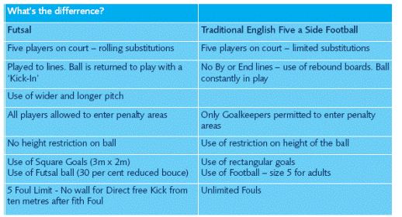

The main differences are in the table. I have highlighted the main rules. These are not all the Futsal rules but the main ones you need to be aware
Goalkeepers
Goalkeepers are allowed to come out of and players are allowed to go into the penalty area (basically, anyone can go into the ‘D’ or goalkeepers area).
A goal clearance must be thrown out.
Kick-ins
In order to restart the game after a ball has gone out of play the ball is kicked back into play from the touchline and from corners. The ball must be placed stationary on the touchline and the feet of the player taking the kick-in must not cross the line. The 4 second rule - For kick-ins, free kicks, goal clearances and corner kicks - the player in possession of the ball has 4 seconds to restart play
ALL players MUST wear shin-pads and indoor training shoes.
Anyone without shin-pads or trainers will NOT be allowed to play.

Rules will be further explained if needed on arrival at the tournament.

