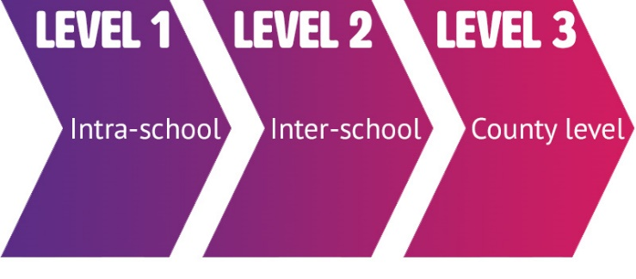

## **Set of Six**

There will be 6 runs and 5 tackles.

If no try occurs in this time the ball will turn over to the other team and the tackle count will be reset to 0.

At the start of play the team with the ball will have 4 remaining tackles.

## **Passing**

The ball can only be passed sideways or backwards through the air, not handed to another player. If the ball is handed to another player or passed or knocked forwards (towards the opponents’ goal- line) then "play the ball".

## **Values Pathway**

To compete in this event schools must qualify through their level 2 competitions in their boroughs.

## **Equipment**

Size 4 ball.

40m x 25m maximum pitch.

Tag belts with 2 tags for each player.

## **Competition Format**

Games should have 2 10 minute periods with a change-over interval of 2 minutes between each session. This can be changed provided both teams agree.

The finals will be will be 10-12 minute games.

## **Teams**

All players must be in year 5 and/or year 6.

Squads can have up to 12 players

8 players on the pitch at a time.

Teams must have a minimum of 4 girls and 4 boys with at least 2 of each gender playing at once.

Substitutions can only occur when the ball is not in play or at half time and must occur with the referee’s knowledge

Teams should be made up of students who do not participate in sporting opportunities outside of school.

.

  
Year 5/6 Tag rugby league

25th march 2020

## **After a Tag**

After a tag, a 'play the ball' must take place. The tagged player places the ball on the ground and, using their foot, rolls the ball backwards to an awaiting player ('acting half back') who must remain stationary until they have passed the ball.

The defensive team must retreat 5m.

The defensive team can’t advance until the 'acting half back' has passed the ball.

## **Object of the Game**

The object of the game is to score a try (4 points) by placing the ball with a downward pressure on or behind the opponents’ goal-line.

For safety, the ball carrier must remain on their feet at all times and they are not allowed to score a try by diving over the goal-line. If a player grounds the ball while on their knees, the try should be allowed but, afterwards, all players should be reminded that they should stay on their feet. A player may not be prevented from grounding the ball by any physical contact (including placing a hand between ball and ground).

Where Tag Rugby is played indoors or in restricted areas, a try can be scored by the ball carrier crossing the vertical plane of the goal-line without grounding the ball. This allows players to have their head up and be aware of their surroundings at all times.

When a try is scored, the game is restarted by a free pass from the centre of the pitch by the non- scoring team.

## **Play the Ball**

A "play the ball" is used to start the match at the beginning of each half from the centre of the pitch, from the side of the pitch when the ball goes into touch at the point where the ball went out of play and from where the referee makes a mark when an infringement has taken place.

At a "play the ball" the opposition must be 7m back from the mark and the receiver needs to be behind the passer. At a "play the ball", the player must start with the ball in both hands and, when instructed by the referee who will call “PLAY”, pass the ball backwards through the air to a member of their team. For safety reasons, no player may run until the pass is made.

If an infringement takes place or the ball goes into touch over the goal-line or within 7m of the goal line, then the "play the ball" must be awarded to the non-offending side 7m from the goal-line. This gives more space for both attacking and defending teams to play in.

After an infringement, knock on or ball out play the restart is from the hands.

## **No kicking of the ball**

## **No Contact**

The only contact allowed between the two teams is the removal of a tag from the belt of the ball carrier. Any other type of contact on the ball carrier, such as shirt pulling, running in front of or barging the ball carrier, forcing the ball carrier into touch, etc must be penalised with a "play the ball" and the players concerned reminded of the rules.

## **Offside**

Offside occurs if the defending team are not in line with the referee or if they move before the pass is made. When a tag is made, all the other players from the tagger’s team must attempt to retire towards their own goal-line until they are behind the ball. If a player, in an offside position, intercepts, prevents or slows down a pass from the tagged player to a team-mate, a "play the ball" will be awarded to the non-offending side. A player can, however, run from an onside position to intercept a floated pass before it reaches the intended receiver.

## **Obstruction**

The ball carrier can run and dodge potential taggers but cannot fend them off using their hands or the ball and cannot guard or shield their tags in any way.

Similarly, the ball carrier or a potential tagger must not deliberately make contact with an opponent.

If such contact is made the game must be stopped, the offender spoken to, reminded of the non-contact rules of tag and a "play the ball" awarded to the non-offending side.

If the ball is pulled from the ball carrier's grasp, a "play the ball" is awarded to the ball carrier's side.

## **The Tag**

All players wear a tag belt around their waist, outside of shirts, with two tags attached to it by Velcro positioned over each hip. Tag belts are to be securely fastened and any excess belt is to be tucked away so that this cannot be pulled by mistake.

A “tag” is the removal of one of the two tags from the ball carrier’s belt. Only the ball carrier can be tagged. The ball carrier can run and dodge potential taggers but cannot fend them off using their hands or the ball and cannot guard or shield their tags in any way. The ball cannot be pulled out of the ball carrier’s hands at any time.

After a player has been tagged their tag must be returned to them and ideally placed back on the belt before continuing play.

If a player does not have two tags on their belt, one on each hip and they become a ball carrier or if they tag an opponent, a "play the ball" will be awarded to the non- offending side at the place of infringement.

## **Spirit Scoring**

After every game, both teams will form one circle with alternating players from each team. A representative from each team will then comment how the teams played, and the Spirit shown.

Each team will then privately rate their opponents on the School Games Values.

Each category is given a score from 0-4 with the ‘Most Spirited’ (highest scoring) team being announced at the end of the event. Remember that a score of 2 is still considered to be a ‘Good’ score. A score of 4 means that they did something REALLY well!

The game score will also contribute, with a win gaining a 4, a draw 2 and a loss 0 on the Spirit Scorecard.

Spirit Scorecards can be found on the GreaterSport website.

## **Fair Play**

The ideals of good sportsmanship and respect should permeate throughout all competitive and recreational sport. They are displayed by someone who abides by the rules of a contest, respects their opponents and accepts victory or defeat graciously.

## **Health and Safety**

Players must wear suitable footwear.

No jewellery to be worn.

All loose clothing must be tucked in and shoelaces tied.

No chewing gum or sweets.

All players are advised to warm up appropriately before each match.

When not competing, players must remain off the pitch and not get in the way or distract officials.

Medical supplies that players may need should be brought with them on the day i.e. asthma inhalers.

All team teachers must ensure their pupils are under adult supervision at all times, even when playing.

## **Ball on the Ground**

If the ball goes to ground, players can pick it up but they must not dive to the floor to recover the ball. If they do a "play the ball" is awarded to the non- offending side and the following rules will apply:

If the ball was lost forward, a "play the ball" is awarded to the non-offending side.

If the ball carrier falls to the ground with the ball then a "play the ball" will be awarded to the non-offending side.

If the passed ball rolls into touch a "play the ball" will commence from the touchline to the non-passing side.

