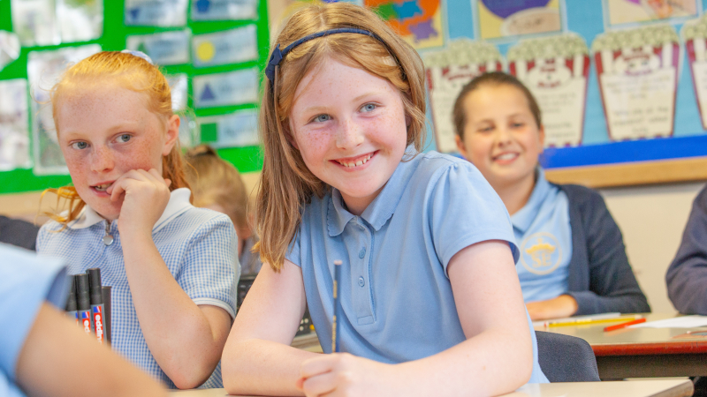
Following the announcement of school closures due to COVID-19, the Youth Sport Trust has been developing new ways to support children and families to stay active during lockdown. The activities, resources and videos have been vital to support our physical, social and emotional wellbeing during this difficult time and have been made available free of charge. Please scroll down to see what's available.
With Government announcements on the easing of lockdown measures, the phased return to school for some primary pupils (Reception, Year 1, 6) from 01 June 2020, as well as some secondary pupils (Year 10, 12), we are now moving our support to help schools manage that transition whilst maintaining our support for those parents that still have children at home. Our 2020/21 school membership offer includes additional services to support schools to respond to COVID-19 - for more information on membership click here.

Guidance Documents
Below, we have outlined the statutory guidance from the Government, devlolved governments, and from our partners at the Association of Physical Education (AfPE) and ukactive.
- Department for Education (DfE) - the latest guidance on how educational and childcare settings should prepare for wider opening from 01 June, includes information on: year groups in the first phase of wider opening, the latest science, managing risk and rate of transmission of coronavirus.
- DfE have also released separate guidance on supporting children and young people with SEND. Plus, guidance for parents and carers on their children attending out of school hours provision.
- On 02 July 2020, DfE released guidance for the full opening of Schools from September 2020. Within the guidance there is a specific section focusing on Physical Activity.
- Department for Culture, Media and Sport (DCMS) - guidance for the public, providers of outdoor sport facilities, elite athletes, personal trainers and coaches on the phased return of sport and recreation.
- Welsh Government
- Scottish Government
- Northern Ireland Government
- Association for Physical Education (AfPE) - a practical self-review tool for COVID-19 risk assessment. Managing risk, maximising opportunity.
- ukactive - advice and guidance for children's activity providers on safe practice and delivery during restrictrions caused by COVID-19.

Our Support

Support for Parents
In this section you will find a range of resources, including the 60 second active challenge series, to support those who still have children at home. The activities, resources and videos are designed to keep you moving, keep you learning and help support your physical, social and emotional wellbeing during lockdown.
CLICK HERE
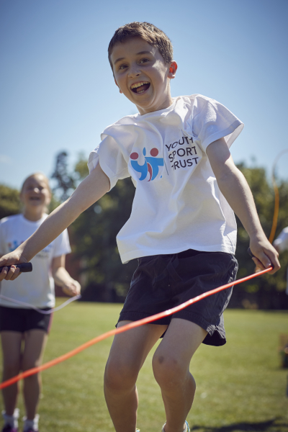

Support for Schools
In this section you will find a range of resources to support the widening of provision in your school with some year groups returning from 01 June. The resources below should be used in line with Government and statutory guidance and are focused on the principles and practicalities of delivering PE and sport under current restrictions.
CLICK HERE
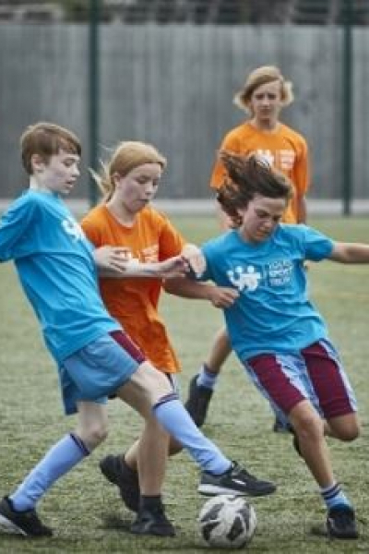

Supporting Sport Partners
In this section we have provided updated information and resources from across the sector in supporting a return to sport. This includes information from Home Country Sports Councils, other sector organisations and international practice.
CLICK HERE

