
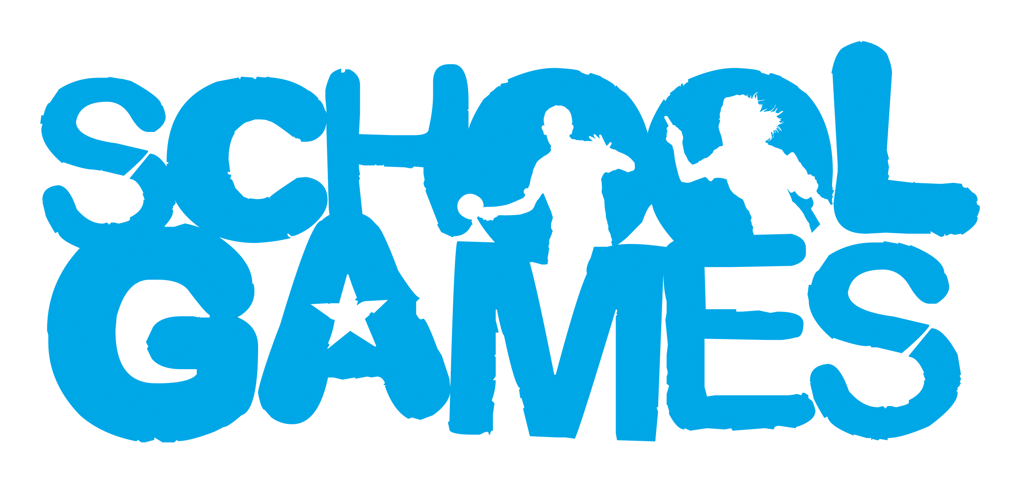

Indoor Hockey rules
As we aim to make every event whether that be a competition or festival, a positive experience for children, we have decided to bring our annual hockey event indoor. We feel that the cold weather we normally have doesn’t create an event that children look forward to but by hosting it in a sports hall we can hopefully increase the enjoyment a little bit more!
INTENT: A competitive event with winners leading to a final
AUDIENCE: Year 5/6 Mixed event. 4 on the pitch and 6 in a squad with min of 2 boys & 2 girls on the pitch.
EQUIPMENT: Indoor hockey sticks will be used (Uni Hoc sticks). We have all the equipment. Air flow balls will be used to slow the ball down on the sports hall floor.

RULES:
- There are no Goalkeepers
- A team consists of 6 players with 4 on the pitch at any one time. The other 2 players must encourage their team from the sideline.
- Players must be rotated throughout the game
- A centre pass is used to start the game
- A centre pass must be taken after each goal is scored by the non-scoring team
- The team must be positioned in their own half on a centre pass and the opposing players must be 3 metres from the ball until the ball is played.
- A goal is scored when the ball is hit from within the shooting circle and hits the bench or is scored in the goal (whichever is used in the hall).
- If a defending player deliberately stops a ball from going in goal with their feet or body then a penalty is awarded or the goal is given.
- A free pass is awarded when the ball hits the back wall or over a line of the court, kicks or propels the ball, a high ball, obstructs their opponent, holds/ charges at/ pushes or kicks another player, interferes with another players stick or any dangerous play.
- The free pass shall be taken where offence occur. If over the back line/ hits back wall from an attacker, then use the top of the circle, if over the back line/ hits back wall from a defender then it is a corner.
- In indoor hockey, both sides of the stick can be used to strike or control the ball.

